Mae Jemison Class

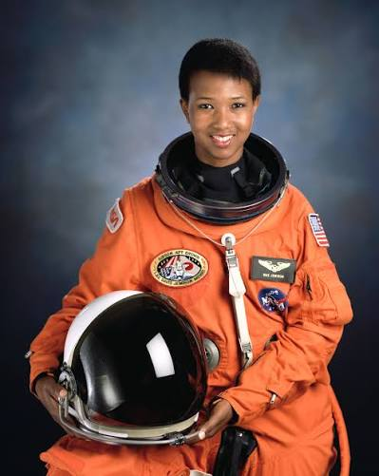
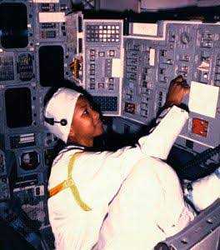

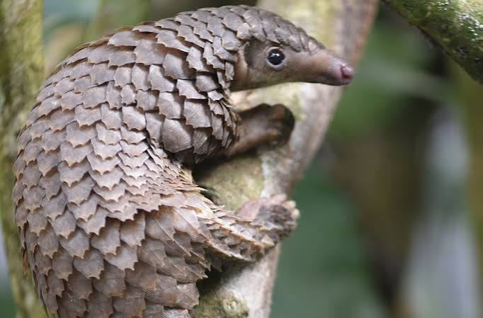



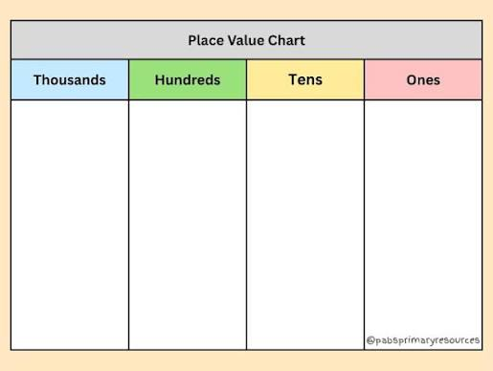

Information for Parents of children in Mae Jemison Class
Year 3
Dear Parents and Carers,
This year, we have chosen famous scientists as our class names. Year 3 will be named after Mae Jemison, the first Black woman in space. Jemison left NASA in 1993 and founded a technology research company. She later formed an educational foundation and, through the foundation, is the principal of the 100 Year Starship project.
In Year 3, we have early morning reading sessions from 8:40 – 9:15am. Please ensure that you are on time for these sessions, as they are hugely important for your learning. We will be focusing on a range of fiction and non-fiction texts throughout Year 3. Our first topic is skeletons and muscles, in which we will be writing a non-chronological report about pangolins.
In RE, we will be looking at The Bible in more depth. Our first topic is ‘What is the story?’, where we will be learning about ordering different stories in the Bible, discussing stories from the Bible and considering why the Bible is so important to Christians.
In Humanities, our first topic will be ‘Why do people live near volcanoes?’. We will be looking at different types of volcanoes, how volcanoes are formed and settlements near volcanoes.
Our first science topic is ‘Mixtures and Separation’, where we will be able to do some amazing experiments to support our learning. Our first Maths topic will be place value.
All of the learning has been specifically designed to help your child achieve the skills outlined in the new national curriculum. Children will be reading, researching, writing, illustrating, working on their own and working in groups to develop their knowledge.
Please discuss with your child the learning they have done as the term progresses and let them teach you.

General Reminders
Punctuality wait with children at gate
School currently starts at 8:40am.
Children in year 3 enter through the gate on Dartmouth Road. Please ensure children arrive on time. This will help us to keep children, parents and staff as safe as possible.
Absence
Please ensure that you contact the school to notify them of any absence from school and the reason for this. A phone call on the day is always appreciated.
Jewellery
For the safety of your child please ensure that they do not wear hoop or drop earrings, necklaces, rings or bracelets to school. Children will be asked to remove such items when at school. Small stud earrings are allowed.
P.E
P.E will be on a Wednesday (afternoon slot). Please ensure your child brings in their P.E kit. It may help to bring it in on Mondays and take at home on Fridays.
Labelling Clothing
Please ensure that all clothing is labelled with your child’s name. We cannot be liable for lost or misplaced clothing that is not clearly labelled.
School lunches/Packed lunches
Please try to ensure that your child does not change their lunch option in the middle of the half term. This causes confusion for the office. If your child has a packed lunch please ensure that the food provided includes healthy options and forms a well-balanced lunch.
Breakfast
Please ensure your child has a healthy breakfast and has a good start to the day.
Bedtimes
It is so important that your child goes to bed at a sensible time. A good night’s sleep will ensure they are ready energised and ready for learning.

Helping your child to learn … How you can help?
English
- Reading records
Your child’s reading record and reading book should be brought to school every day. It is important that you read with your child at home. Ideally you should try to read with them for 20 minutes every night. Every Monday, Wednesday and Friday your child’s reading record will be checked. It is imperative your child write’s their own comment in their reading record each day: commenting on great examples of ambitious vocabulary, MORERAPS (Metaphor, Onomatopoeia, Repetition, Emotion, Rhyme, Alliteration, Personification, Simile), punctuation used and what they have enjoyed or did not enjoy about the current text they are reading.
Regular practise is the key to achieving greater confidence
and fluency in reading as well as continued enjoyment.
- Spelling
There are many simple ways that you can help your child to learn spellings at home. For example you could…
- Read the words to your child as well as listening to them reading to you.
- Display the words around the house. This could be done by making labels to stick on cupboards, fridges and doors.
- Play games like snap and matching pairs.
Year 3/4Statutory Spelling List

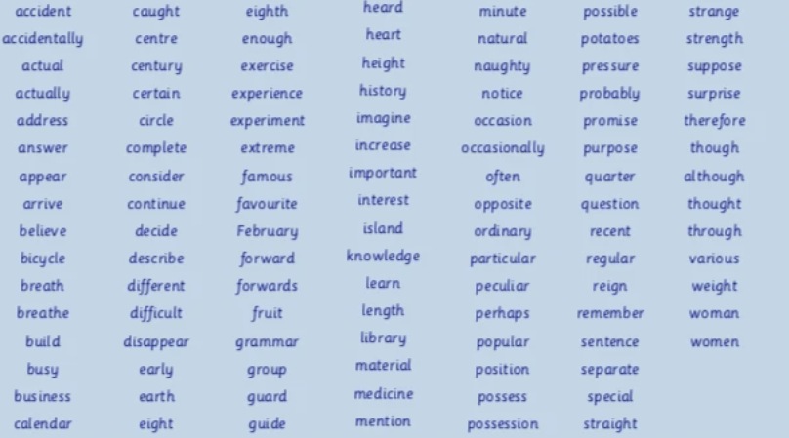

Maths

One of the most important elements in maths learning is
for your child to have a clear understanding of numbers.

This includes them being able to …

- Understand the value of digits in numbers up to the thousands
- Know all the different ways to make a total of 100–for example; 65+35 = 100 (number bonds)
- Time Tables – Children should know all tables to 12 by the time they get to Y5.

It would be helpful if you could practice these skills at home with your child, revisiting these activities regularly to secure your child’s understanding.

By carrying out these simple activities you will be providing a huge boost to your child’s learning and progress over this coming year.
Home Learning
Home Learning is outlined below and will be set each Friday for return on the following Thursday.
Pack of home learning
- Daily reading at home using books from home or school recorded in their reading journal with parental comments and brought to school every day.
- a piece of English home learning – linked to the learning covered that week.
- a piece of Maths home learning – linked to the learning covered that week.
- Spellings – for the children to learn. The children will need to know these for a weekly test each Wednesday.

We hope this pack gives you a clear understanding of what your child will be doing this term. We appreciate your support and if you need to discuss any matters with us, please feel free to ask any questions.

Thank you.

Miss Billing, Miss Pendleton & Mrs. Williams

