
2026-27 Curriculum Overview
 | Autumn 1 | Autumn 2 | Spring 1 | Spring 2 | Summer 1 | Summer2
Topic for the term | Amazing Animals and Phenomenal Places | Looking Back in Time | Our Wonderful World | Interesting Inventions | Happy Homes and Scenic Streets | Excellent Egyptians
Trip |  | Theatre trip | Hindu temple |  |  | Beach trip
Literacy Leaves  (Reading) | Africa, Amazing Africa | TBC | Lost Species | After the Fall | The Street Beneath my Feet | The Lost Spells
English | Skeletons and Muscles (Non-chronological report)  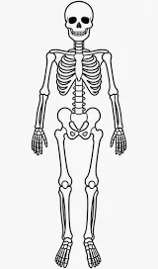 | The Secret of Black Rock (narrative)  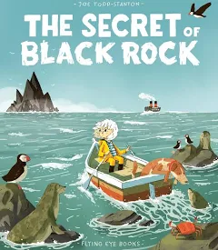 | Climate action (magazine article)   | How a robot dog works (explanation)  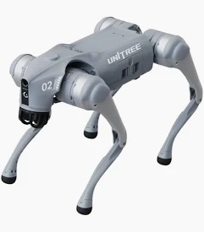 | 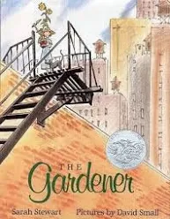  The Gardener (letter)  The True Story of the Three Little Pigs (narrative)  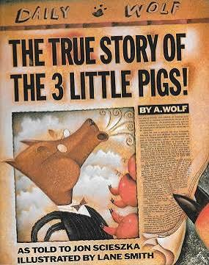 | The Egyptian Story: Inside the Pyramid  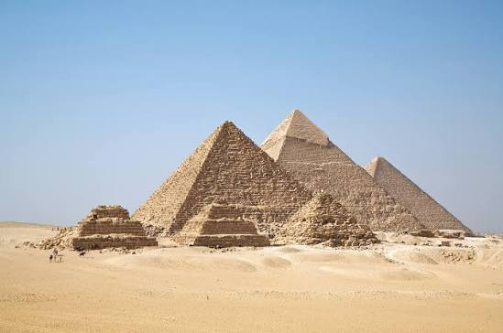
Maths | Place Value  Addition & Subtraction | Multiplication & Division A & B | Fractions A & B | Money  Time | Shape  Statistics | Length & Perimeter  Mass & Capacity
Science | Animals: movement and nutrition | Forces & magnets | Rocks & soil | Light & shadows | Plant reproduction | Making connections: Does hand span affect grip strength?
RE | What is the story? | Why do we remember?  What is the most important message of Christmas? | What does it mean to be a Hindu in Britain today? | What kind of world does God want?  How is each person vital to the Easter narrative? | Why should Hindus live a good life? | Words and actions - which is most important?
History |  | Would you prefer to have lived in the Stone Age, Bronze Age or Iron Age? |  | Why did the Romans invade and settle in Britain? |  | What was important to ancient Egyptians?
Geography | Why do people live near volcanoes? |  | Who lives in Antarctica? |  | Are all settlements the same?
Art | Prehistoric painting | Exploring texture with paint and collage | Abstract shape and space | Developing drawing skills | TBC | Ancient Egyptian scrolls
Computing | Networks | Scratch | Online safety | Journey inside a computer | Using iPads | Emailing  Comparison cards databases
Music | RECORDER
PE | PE - MISS JAMIE
PSHE/RSE | How can I take care of my mind and body? | What helps us feel safe and included? | How should we communicate online? | What rights and responsibilities do we have? | How can we prevent illness and injury and respond if they happen? | What careers do people choose and why?
MFL | ITALIAN

